**Site Structure and Navigation Report**

X00044772 - X00130951

Philip Tubman – Aoife Skelly

**Topic Details:**

We decided to choose a pet accessories website as our topic for our website. We came up with the idea because we feel there is room in the market for the products that we sell. A lot of houses have pets whether it is a dog, cat or small animal so you can’t go wrong with a website that has loads of toys and items for the pets to play with. Pets are part of the family and people like to make their pets happy. We decided our company would deal with charities since donating our profits to them would be for a great cause. It was a way for us to show our users that we really love helping and caring for animals, it isn’t just about the products we have to offer!

**Layout and Colour Scheme:**

We drew out how we wanted our website to look and we came up with the conclusion that we would keep the detail and layout of our website simple. We wanted to choose a colour scheme that would be easy on the eye which is why we went with the greys, blacks and whites. We knew these colours would work well since the toys and items we sell are quite colourful already. The items on the pages stand out because the colours surrounding them do not take over the user’s eye. We have researched similar websites and we kept our websites to a similar theme so it would not be an outcast but we still wanted to put our own touch on it. To make things different we decided to add in a tips page, which allows our users to read up on useful tips about having a pet. We also felt it was a good idea to have a small side nav which links back to the products no matter what page the user is on. The reason we felt it was useful to have the side nav there at all times was because when we were on other pet accessories websites sometimes it was quite hard to get back to the product page of whatever pet you were interested in. We knew that if it was at the side of the page it would only be a matter of a simple click and they would be back to the products they wanted to look at.

**Target Audience:**

Our target Audience is for people who have pets and also for those who love animals or would like to have a pet. People who do not already have pets might not find our website as useful as those who do, since they would not be focused on buying products however if they have a passion or love for animals they might decide to donate to the charities that we have discussed on our services page.

**Images and Media Content:**

Both of our team members participated together in the creation of this website and the layout and designed. We worked really well together as a team and we both contributed equally to each aspect of the project. We looked for pet animal images online and we picked the ones we thought would best suit our website. We tried to keep our images joyful and playful to stand out. We choose appropriate images for the banners in the website. We put in a dog banner if the user was viewing the dog products and we did the same for each category. We used the images for our logos and such as the charity logos. We felt it was necessary to have images on each page to make the website look more attractive. We kept the design of each page consistent throughout the site.

**Our Site Structure:**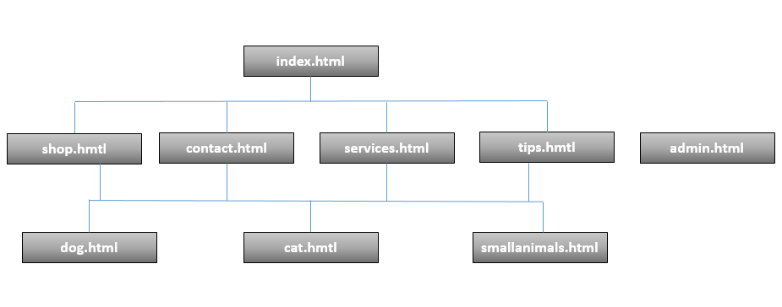

Cat, dog and small animals are linked to everything as they are the pages on part of the side nav which is always visible and accessible.

We have the admin page in the diagram to show that when logged in as an administrator you can access the form on that page. We did not connect that page to the others since it is not always there. It is only visible for admins.

Below is an outline of what our website looks like.

